Test Summary Report for
Restful Booker API

General information
Project Name | Restful Booker API
Created by (Author) | Dishi Gogia
Preparation date | 20/06/2026
Version | V1.0

Revision History
Version | Description | Author | Date | Approved by
 |  |  |  | Author | Date
V1.0 | Test Summary | Dishi Gogia | 20-06-2026

Summary
Table of Contents
Executive Summary 5
Introduction 5
Overview 5
Summary Assessment 5
Test Case Summary Results 5
Test Incident Summary Results 6
Test Metrics 6
Executive Summary Table 6
Test Execution Results 7
Defect Distribution by Severity 7
Test Coverage by Module 8
DETAILED TEST RESULTS 8
1. Authentication API 8
2. Create Booking API 8
3. Get Booking API 8
4. Update Booking API 8
5. Partial Update API 9
6. Delete Booking API 9
7. Search Booking API 9
VARIANCES 9
TEST INCIDENTS 9
Resolved Test Incidents 9
Unresolved Test Incidents 9
FINAL TEST STATUS 10

Executive Summary

The Restful Booker API Testing project was executed to validate the functionality, reliability, and correctness of core booking APIs using Postman. A total of 64 test cases were designed and executed across Authentication, Booking Management, Search, and API Validation modules. Overall execution achieved a 92% pass rate, with 5 defects identified primarily in authorization and update-related functionality. The application demonstrated stable behavior for core business workflows and is conditionally recommended for release pending resolution of identified issues.

Introduction

Overview

The purpose of this Test Summary Report is to provide a consolidated summary of testing activities performed for the Restful Booker API application.
Testing was conducted using Postman to validate the functionality, reliability, and correctness of REST APIs exposed by the application. The testing effort focused on Authentication, Create Booking, Get Booking, Update Booking, Partial Update, Delete Booking, and Search Booking APIs.
Testing activities included:
• Functional Testing
• Positive Testing
• Negative Testing
• Authorization Testing
• Response Validation
• Status Code Validation
• Header Validation
• API Workflow Validation

Summary Assessment

Test Case Summary Results

Summary Assessment | Total Number of Test Cases | % of Total Planned | Comments
Test Cases Planned | 64 | 100% | Planned API test cases
Test Cases Run | 64 | 100% | All planned test cases executed
Test Cases Reviewed | 64 | 100% | Results reviewed
Test Cases Passed | 59 | 92% | Passed successfully
Test Cases Failed | 5 | 8% | Failed due to environment/API behaviour
Test Cases To Be Run | 0 | 0% | No pending tests
Test Cases Held | 0 | 0% | No tests on hold

Test Incident Summary Results
Impact / Severity | Total Reported | Total Resolved | % Resolved | Total Unresolved | % Unresolved
High | 1 | 0 | 0% | 1 | 100%
Medium | 3 | 0 | 0% | 3 | 100%
Low | 1 | 0 | 0% | 1 | 100%
Total | 5 | 0 | 0% | 5 | 100%

Test Metrics

KPI | Value
Total Test Cases | 64
Executed | 64
Passed | 59
Failed | 5
Pass Rate | 92%
Defects Logged | 5
Test Coverage | 100%
Execution Progress | 100%

Executive Summary Table

KPI | Value
Total Test Cases | 64
Executed | 64
Passed | 59
Failed | 5
Pass Rate | 92%
Defects Logged | 5
Test Coverage | 100%
Overall Status | Conditionally Passed

Test Execution Results
A total of 64 test cases were executed. 59 test cases passed successfully, resulting in a pass rate of 92%, while 5 test cases failed due to environment-related API behavior.

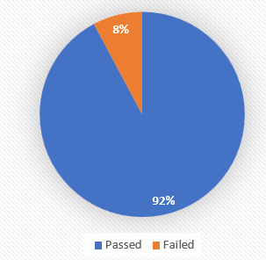

Defect Distribution by Severity
A total of 5 defects were identified during testing. Most defects were categorized as Medium severity, indicating moderate impact on application functionality.

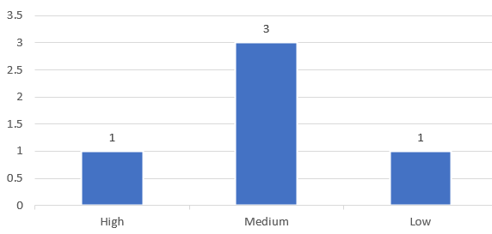

Test Coverage by Module

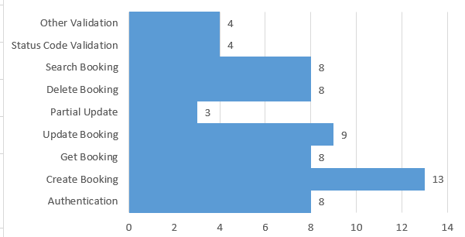

DETAILED TEST RESULTS

Authentication API
Results:
• Token generation validated successfully
• Positive and negative scenarios executed
• Response validation completed
Success Rate: 100%
Scenarios Covered: 8

Create Booking API
Results:
• Booking creation validated successfully
• Mandatory field validations executed
• Invalid data scenarios tested
Success Rate: 100%
Scenarios Covered: 13

3. Get Booking API
Results:
• Booking retrieval validated
• Response structure validated
• Invalid ID scenarios executed
Success Rate: 100%
Scenarios Covered: 8

4. Update Booking API
Results:
• Authorization-related inconsistencies observed
• Update operations returned 403/405 responses in public environment
Success Rate: 67%
Scenarios Covered: 9
Defects Logged: BUG-001, BUG-002

5. Partial Update API
Results:
• Partial update functionality validated
• Authentication validation completed
Success Rate: 67%
Scenarios Covered: 3

6. Delete Booking API
Results:
• Delete operations validated
• Post-deletion verification completed
Success Rate: 88%
Scenarios Covered: 8

7. Search Booking API
Results:
• Search functionality validated
• Query parameter validation completed
Success Rate: 100%
Scenarios Covered: 8

VARIANCES
The following variances were observed during testing:
• Public API environment exhibited inconsistent authorization behaviour.
• Certain Update and Partial Update scenarios returned unexpected HTTP status codes.
• Public environment limitations impacted repeatability of a small number of test cases.
No deviations were observed in overall testing scope.

TEST INCIDENTS

Resolved Test Incidents
None

Unresolved Test Incidents

Bug ID | Summary | Severity | Status
Bug_001 | Update Booking API returned 403 Forbidden despite valid authentication credentials. | High | Open
Bug_002 | Update Booking API returned 405 Method Not Allowed for valid update request. | Medium | Open
Bug_003 | Inconsistent behaviour observed during authorization validation. | Medium | Open
Bug_004 | Unexpected status code returned for unsupported request method. | Medium | Open
Bug_005 | Delete API returned inconsistent response during repeated execution. | Low | Open

FINAL TEST STATUS

Overall Status: Conditionally Passed

Core business workflows, including Authentication, Create Booking, Get Booking, Search Booking, and Delete Booking APIs, were successfully validated. Identified defects are primarily related to authorization behavior and update operations within the public test environment. Based on the executed scope and observed results, the application is considered functionally stable for core operations, with recommended follow-up actions for the identified issues.

